**CAPSTONE PROJECT**

Program: B. Tech (CSE) 6th semester

Course Code: CIS335

Session 2022-2023

CT University, Ludhiana

Submitted In partial fulfilment of the requirement for the award of the Degree of Bachelors of Computer Science and Engineering



**Submitted By: Submitted To:**

Gurleen Kaur Arneja (72010212) SOET Dep.

Prerna kumari (72011500)

Ramandeep kaur(72111867)

Shiwani (72013379)

**Introduction:**

Welcome to BEROTOT, your ultimate fitness destination! We are thrilled to introduce you to a world of strength, wellness, and transformation. Whether you are an experienced fitness enthusiast or a beginner taking the first steps towards a healthier lifestyle, our gym is designed to cater to your every need.

At BEROTOT, we believe that fitness is not just a goal but a way of life. Our state-of-the-art facility is equipped with top-of-the-line equipment and staffed with highly trained professionals who are dedicated to helping you reach your fitness goals. We offer a wide range of fitness programs, classes, and personalized training options to ensure you have all the necessary resources to succeed.

Step into our welcoming and energetic atmosphere, where you'll find a community of like-minded individuals who are passionate about fitness. Our supportive and friendly environment will motivate you to push your limits and achieve new milestones. Whether you're looking to build muscle, lose weight, increase flexibility, or simply improve your overall well-being, we have the tools and expertise to guide you on your fitness journey.

At BEROTOT, we understand that everyone is unique, and that's why we offer personalized fitness plans tailored to your individual needs and preferences. Our team of certified trainers will work closely with you to create a customized program that fits your schedule, goals, and fitness level. We are here to provide the guidance, encouragement, and accountability you need to stay motivated and stay on track.

Beyond the physical aspects of fitness, we also prioritize your mental and emotional well-being. Our gym offers a range of wellness services, including yoga classes, meditation sessions, and nutritional guidance. We believe a holistic fitness approach is essential for achieving long-term success and happiness.

Join us at BEROTOT and experience a fitness journey like no other. Discover the power within you and unlock your full potential. Whether you're striving for a healthier lifestyle, aiming for athletic excellence, or simply looking to have fun while staying fit, we have everything you need to make it happen.

Take the first step towards a stronger, fitter, and healthier you. Explore our website, check out our facilities, and learn more about our programs and services. We can't wait to welcome you to the BEROTOT family and be a part of your transformational journey. Let's embark on this incredible adventure together!

**Preview of our website:**

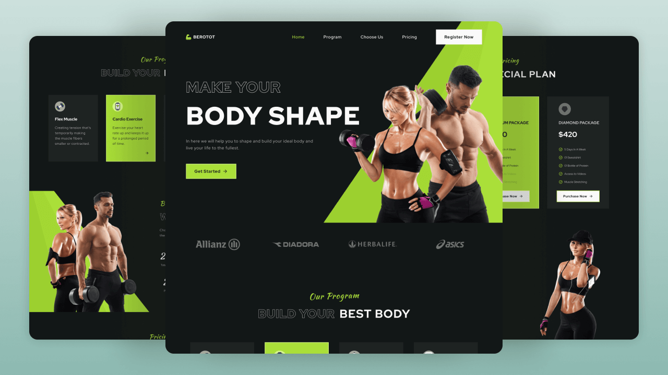

**This is how my file is kept in my laptop:**

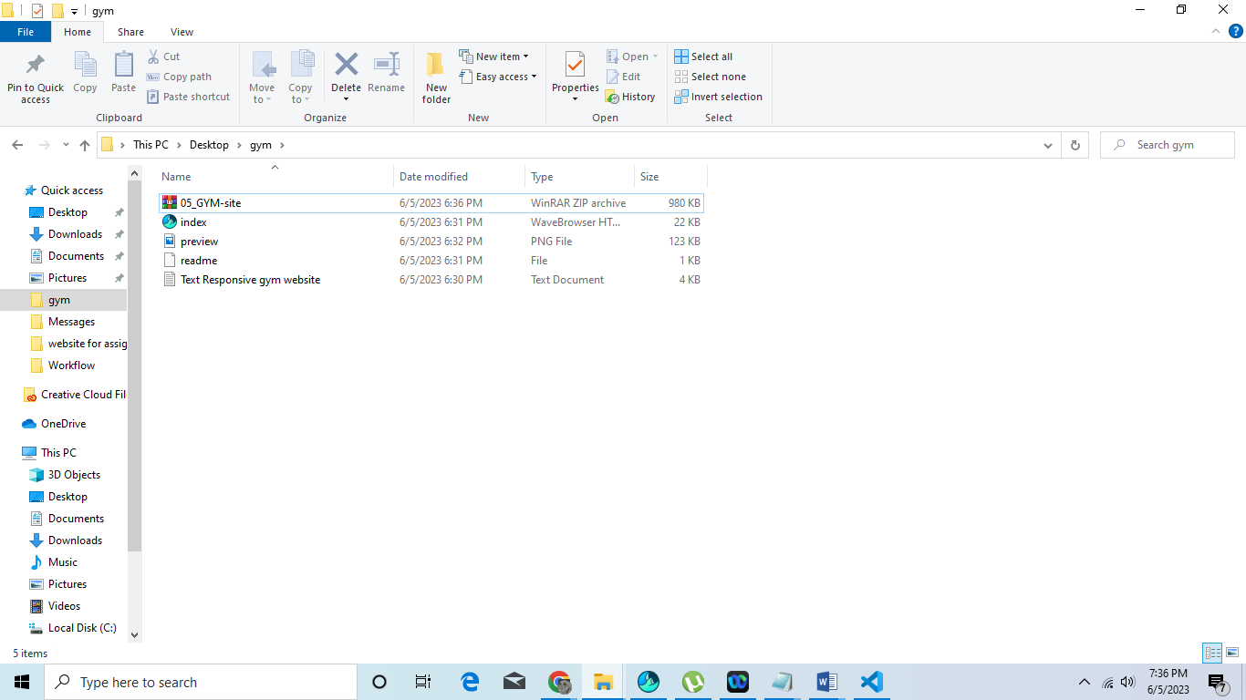

**Look my website deeply:**

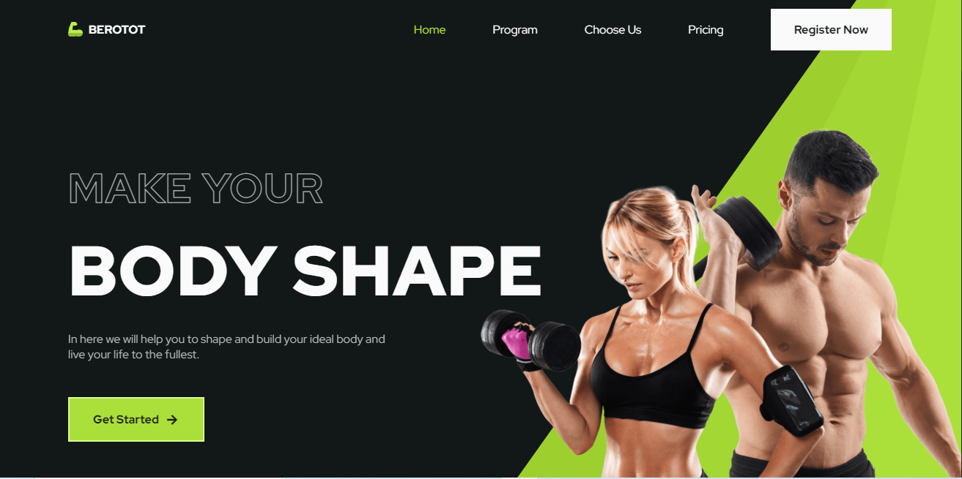

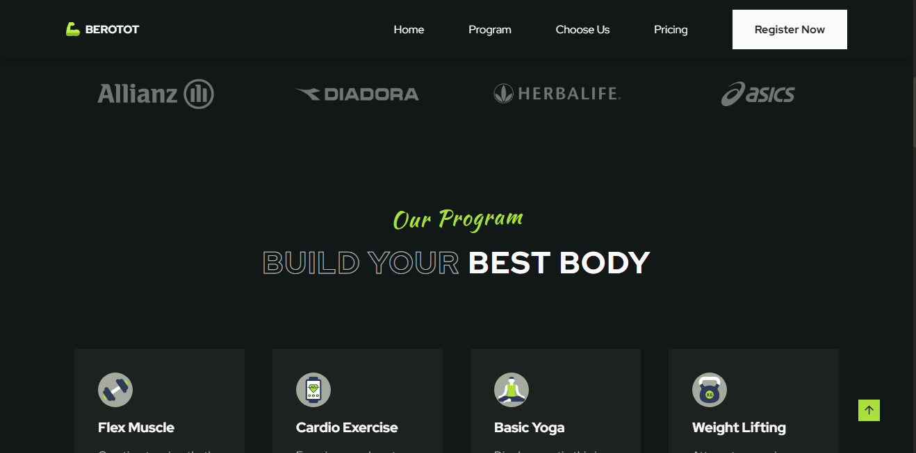

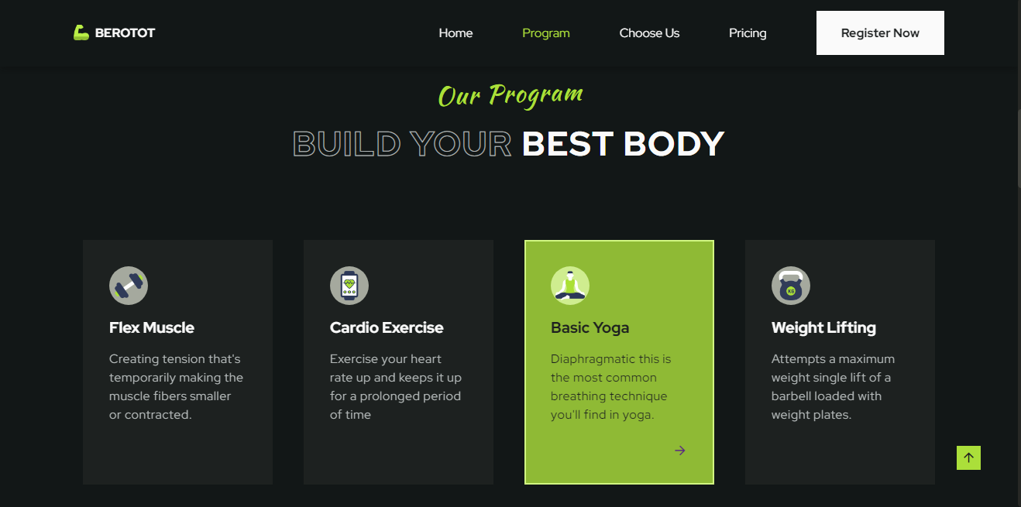

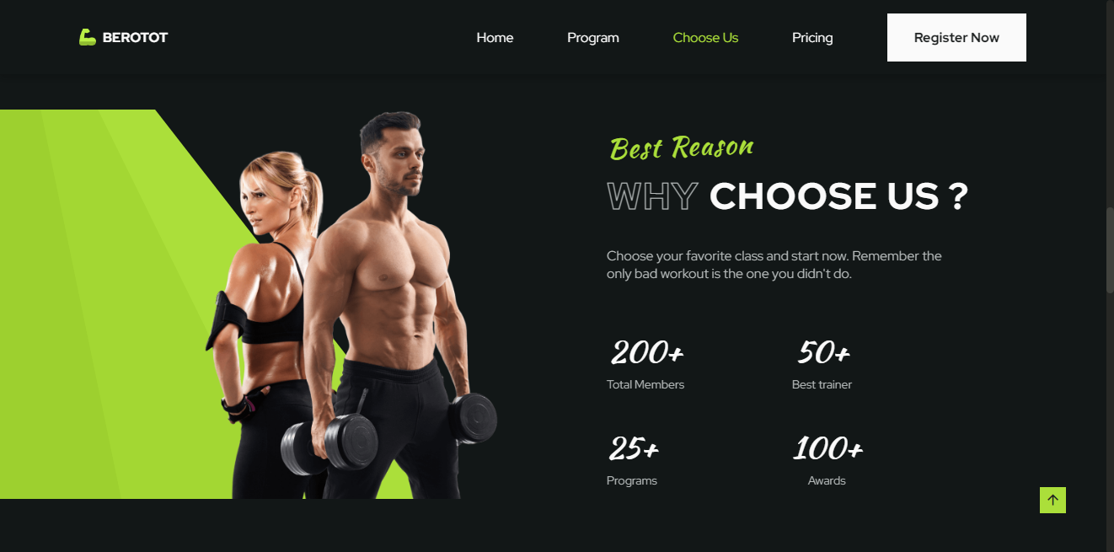

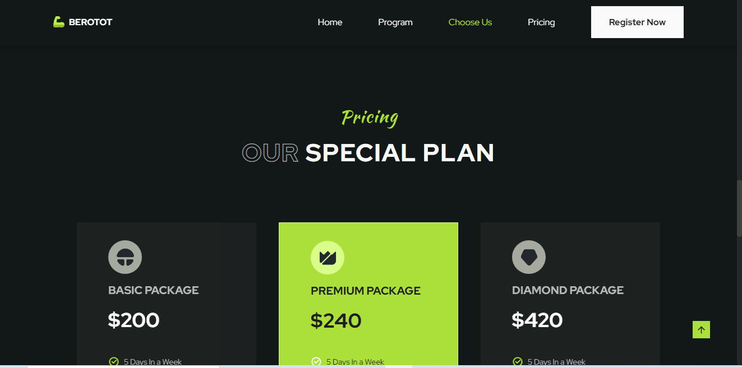

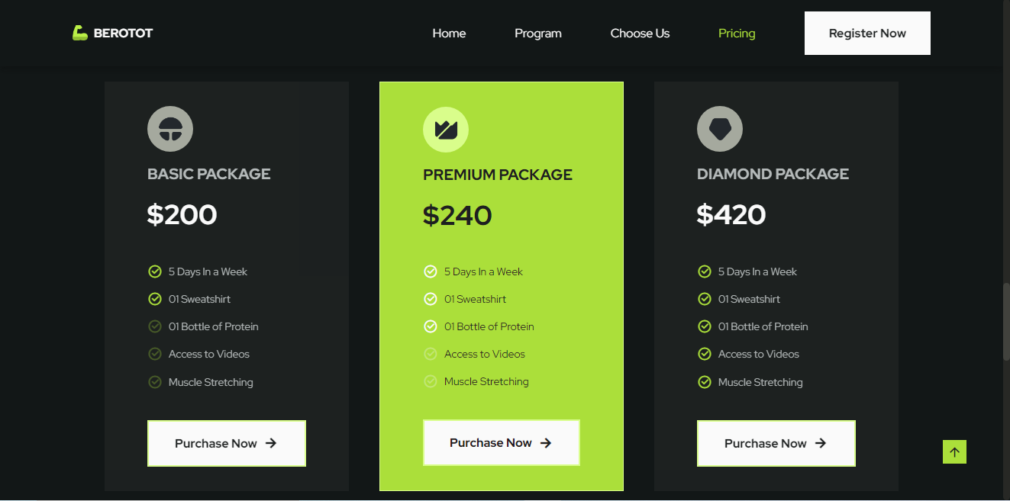

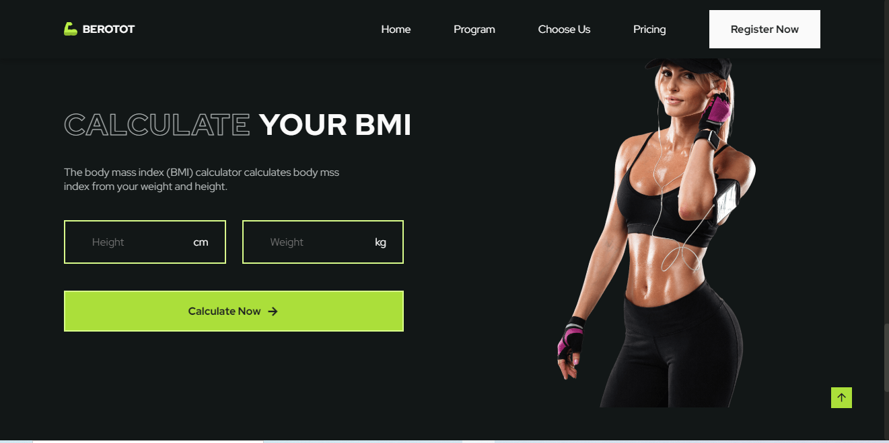

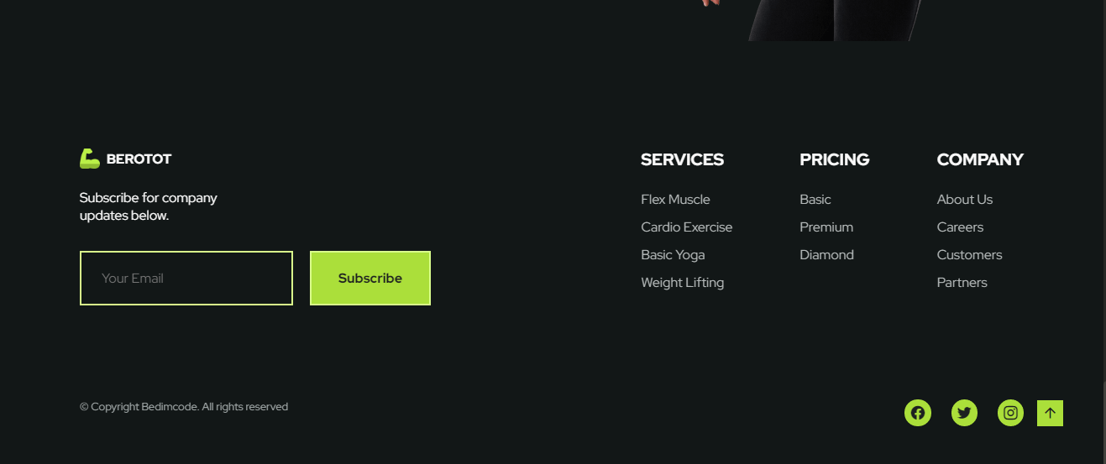

**INDEX CODING:**

<!DOCTYPE html>

<html lang="en">

<head>

<meta charset="UTF-8">

<meta name="viewport" content="width=device-width, initial-scale=1.0">

<!--=============== FAVICON ===============-->

<link rel="shortcut icon" href="assets/img/favicon.png" type="image/x-icon">

<!--=============== REMIXICON ===============-->

<link href="https://cdn.jsdelivr.net/npm/remixicon@2.5.0/fonts/remixicon.css" rel="stylesheet">

<!--=============== CSS ===============-->

<link rel="stylesheet" href="assets/css/styles.css">

<title>Responsive gym website - Bedimcode</title>

</head>

<body>

<!--==================== HEADER ====================-->

<header class="header" id="header">

<nav class="nav container">

<a href="#" class="nav__logo">

<img src="assets/img/logo-nav.png" alt="logo"> BEROTOT

</a>

<div class="nav__menu" id="nav-menu">

<ul class="nav__list">

<li class="nav__item">

<a href="#home" class="nav__link">Home</a>

</li>

<li class="nav__item">

<a href="#program" class="nav__link">Program</a>

</li>

<li class="nav__item">

<a href="#choose" class="nav__link">Choose Us</a>

</li>

<li class="nav__item">

<a href="#pricing" class="nav__link">Pricing</a>

</li>

<div class="nav__link">

<a href="#footer" class="button nav__button">

Register Now

</a>

</div>

</ul>

<div class="nav__close" id="nav-close">

<i class="ri-close-line"></i>

</div>

</div>

<!-- Toggle button -->

<div class="nav__toggle" id="nav-toggle">

<i class="ri-menu-line"></i>

</div>

</nav>

</header>

<!--==================== MAIN ====================-->

<main class="main">

<!--==================== HOME ====================-->

<section class="home section" id="home">

<div class="home__container container grid">

<div class="home__data">

<h2 class="home__subtitle">MAKE YOUR</h2>

<h1 class="home__title">BODY SHAPE</h1>

<p class="home__description">

In here we will help you to shape and build your ideal

body and live your life to the fullest.

</p>

<a href="#" class="button button__flex">

Get Started <i class="ri-arrow-right-line"></i>

</a>

</div>

<div class="home__images">

<img src="assets/img/home-img.png" alt="home image" class="home__img">

<div class="home__triangle home__triangle-3"></div>

<div class="home__triangle home__triangle-2"></div>

<div class="home__triangle home__triangle-1"></div>

</div>

</div>

</section>

<!--==================== LOGOS ====================-->

<section class="logos section">

<div class="logos__container container grid">

<img src="assets/img/logo1.png" alt="logo image" class="logo__img">

<img src="assets/img/logo2.png" alt="logo image" class="logo__img">

<img src="assets/img/logo3.png" alt="logo image" class="logo__img">

<img src="assets/img/logo4.png" alt="logo image" class="logo__img">

</div>

</section>

<!--==================== PROGRAM ====================-->

<section class="program section" id="program">

<div class="container">

<div class="section__data">

<h2 class="section__subtitle">Our Program</h2>

<div class="section__titles">

<h1 class="section__title-border">BUILD YOUR</h1>

<h1 class="section__title">BEST BODY</h1>

</div>

</div>

<div class="program__container grid">

<article class="program__card">

<div class="program__shape">

<img src="assets/img/program1.png" alt="program image" class="program__img">

</div>

<h3 class="program__title">Flex Muscle</h3>

<p class="program__description">

Creating tension that's temporarily making the muscle fibers smaller or contracted.

</p>

<a href="" class="program__button">

<i class="ri-arrow-right-line"></i>

</a>

</article>

<article class="program__card">

<div class="program__shape">

<img src="assets/img/program2.png" alt="program image" class="program__img">

</div>

<h3 class="program__title">Cardio Exercise</h3>

<p class="program__description">

Exercise your heart rate up and keeps it up for a prolonged period of time

</p>

<a href="" class="program__button">

<i class="ri-arrow-right-line"></i>

</a>

</article>

<article class="program__card">

<div class="program__shape">

<img src="assets/img/program3.png" alt="program image" class="program__img">

</div>

<h3 class="program__title">Basic Yoga</h3>

<p class="program__description">

Diaphragmatic this is the most common breathing technique you'll find in yoga.

</p>

<a href="" class="program__button">

<i class="ri-arrow-right-line"></i>

</a>

</article>

<article class="program__card">

<div class="program__shape">

<img src="assets/img/program4.png" alt="program image" class="program__img">

</div>

<h3 class="program__title">Weight Lifting</h3>

<p class="program__description">

Attempts a maximum weight single lift of a barbell loaded with weight plates.

</p>

<a href="" class="program__button">

<i class="ri-arrow-right-line"></i>

</a>

</article>

</div>

</div>

</section>

<!--==================== CHOOSE US ====================-->

<section class="choose section" id="choose">

<div class="choose__overflow">

<div class="choose__container container grid">

<div class="choose__content">

<div class="section__data">

<h2 class="section__subtitle">Best Reason</h2>

<div class="section__titles">

<h1 class="section__title-border">WHY</h1>

<h1 class="section__title">CHOOSE US ?</h1>

</div>

</div>

<p class="choose__description">

Choose your favorite class and start now. Remember the only bad workout is the one you

didn't do.

</p>

<div class="choose__data">

<div class="choose__group">

<h3 class="choose__number">200+</h3>

<p class="choose__subtitle">Total Members</p>

</div>

<div class="choose__group">

<h3 class="choose__number">50+</h3>

<p class="choose__subtitle">Best trainer</p>

</div>

<div class="choose__group">

<h3 class="choose__number">25+</h3>

<p class="choose__subtitle">Programs</p>

</div>

<div class="choose__group">

<h3 class="choose__number">100+</h3>

<p class="choose__subtitle">Awards</p>

</div>

</div>

</div>

<div class="choose__images">

<img src="assets/img/choose-img.png" alt="choose image" class="choose__img">

<div class="choose__triangle choose__triangle-1"></div>

<div class="choose__triangle choose__triangle-2"></div>

<div class="choose__triangle choose__triangle-3"></div>

</div>

</div>

</div>

</section>

<!--==================== PRICING ====================-->

<section class="pricing section" id="pricing">

<div class="container">

<div class="section__data">

<h2 class="section__subtitle">Pricing</h2>

<div class="section__titles">

<h1 class="section__title-border">OUR</h1>

<h1 class="section__title">SPECIAL PLAN</h1>

</div>

</div>

<div class="pricing__container grid">

<article class="pricing__card">

<header class="pricing__header">

<div class="pricing__shape">

<img src="assets/img/pricing1.png" alt="pricing image" class="pricing__img">

</div>

<h1 class="pricing__title">BASIC PACKAGE</h1>

<h2 class="pricing__number">$200</h2>

</header>

<ul class="pricing__list">

<li class="pricing__item">

<i class="ri-checkbox-circle-line"></i> 5 Days In a Week

</li>

<li class="pricing__item">

<i class="ri-checkbox-circle-line"></i> 01 Sweatshirt

</li>

<li class="pricing__item">

<i class="ri-checkbox-circle-line pricing__item-opacity"></i> 01 Bottle of Protein

</li>

<li class="pricing__item">

<i class="ri-checkbox-circle-line pricing__item-opacity"></i> Access to Videos

</li>

<li class="pricing__item">

<i class="ri-checkbox-circle-line pricing__item-opacity"></i> Muscle Stretching

</li>

</ul>

<a href="" class="button button__flex pricing__button">

Purchase Now <i class="ri-arrow-right-line"></i>

</a>

</article>

<article class="pricing__card pricing__card-active">

<header class="pricing__header">

<div class="pricing__shape">

<img src="assets/img/pricing2.png" alt="pricing image" class="pricing__img">

</div>

<h1 class="pricing__title">PREMIUM PACKAGE</h1>

<h2 class="pricing__number">$240</h2>

</header>

<ul class="pricing__list">

<li class="pricing__item">

<i class="ri-checkbox-circle-line"></i> 5 Days In a Week

</li>

<li class="pricing__item">

<i class="ri-checkbox-circle-line"></i> 01 Sweatshirt

</li>

<li class="pricing__item">

<i class="ri-checkbox-circle-line"></i> 01 Bottle of Protein

</li>

<li class="pricing__item">

<i class="ri-checkbox-circle-line pricing__item-opacity "></i> Access to Videos

</li>

<li class="pricing__item">

<i class="ri-checkbox-circle-line pricing__item-opacity"></i> Muscle Stretching

</li>

</ul>

<a href="" class="button button__flex pricing__button">

Purchase Now <i class="ri-arrow-right-line"></i>

</a>

</article>

<article class="pricing__card">

<header class="pricing__header">

<div class="pricing__shape">

<img src="assets/img/pricing3.png" alt="pricing image" class="pricing__img">

</div>

<h1 class="pricing__title">DIAMOND PACKAGE</h1>

<h2 class="pricing__number">$420</h2>

</header>

<ul class="pricing__list">

<li class="pricing__item">

<i class="ri-checkbox-circle-line"></i> 5 Days In a Week

</li>

<li class="pricing__item">

<i class="ri-checkbox-circle-line"></i> 01 Sweatshirt

</li>

<li class="pricing__item">

<i class="ri-checkbox-circle-line"></i> 01 Bottle of Protein

</li>

<li class="pricing__item">

<i class="ri-checkbox-circle-line"></i> Access to Videos

</li>

<li class="pricing__item">

<i class="ri-checkbox-circle-line"></i> Muscle Stretching

</li>

</ul>

<a href="" class="button button__flex pricing__button">

Purchase Now <i class="ri-arrow-right-line"></i>

</a>

</article>

</div>

</div>

</section>

<!--==================== CALCULATE ====================-->

<section class="calculate section">

<div class="calculate__container container grid">

<div class="calculate__content">

<div class="section__titles">

<h1 class="section__title-border">CALCULATE</h1>

<h1 class="section__title">YOUR BMI</h1>

</div>

<p class="calculate__description">

The body mass index (BMI) calculator calculates body mss index from your weight and height.

</p>

<form class="calculate__form" id="calculate-form">

<div class="calculate__box">

<input type="number" placeholder="Height" class="calculate__input" id="calculate-cm">

<label class="calculate__label">cm</label>

</div>

<div class="calculate__box">

<input type="number" placeholder="Weight" class="calculate__input" id="calculate-kg">

<label class="calculate__label">kg</label>

</div>

<button type="submit" class="button button__flex">

Calculate Now <i class="ri-arrow-right-line"></i>

</button>

</form>

<p class="calculate__message" id="calculate-message"></p>

</div>

<img src="assets/img/calculate-img.png" alt="calculate image" class="calculate__img">

</div>

</section>

</main>

<!--==================== FOOTER ====================-->

<footer class="footer section" id="footer">

<div class="footer__container container grid">

<div>

<a href="#" class="footer__logo">

<img src="assets/img/logo-nav.png" alt="">BEROTOT

</a>

<p class="footer__description">

Subscribe for company <br> updates below.

</p>

<form action="" class="footer__form" id="contact-form">

<input type="email" name="user_email" placeholder="Your Email" class="footer__input"

id="contact-user">

<input type="submit" class="button" id="Subscribe-btn" value="Subscribe">

</form>

<p class="footer__message" id="contact-message"></p>

</div>

<div class="footer__content">

<div>

<h3 class="footer__title">

SERVICES

</h3>

<ul class="footer__links">

<li>

<a href="#" class="footer__link">Flex Muscle</a>

</li>

<li>

<a href="#" class="footer__link">Cardio Exercise</a>

</li>

<li>

<a href="#" class="footer__link">Basic Yoga</a>

</li>

<li>

<a href="#" class="footer__link">Weight Lifting</a>

</li>

</ul>

</div>

<div>

<h3 class="footer__title">

PRICING

</h3>

<ul class="footer__links">

<li>

<a href="#" class="footer__link">Basic</a>

</li>

<li>

<a href="#" class="footer__link">Premium</a>

</li>

<li>

<a href="#" class="footer__link">Diamond</a>

</li>

</ul>

</div>

<div>

<h3 class="footer__title">

COMPANY

</h3>

<ul class="footer__links">

<li>

<a href="#" class="footer__link">About Us</a>

</li>

<li>

<a href="#" class="footer__link">Careers</a>

</li>

<li>

<a href="#" class="footer__link">Customers</a>

</li>

<li>

<a href="#" class="footer__link">Partners</a>

</li>

</ul>

</div>

</div>

</div>

<div class="container">

<div class="footer__group">

<ul class="footer__social">

<a href="https://www.facebook.com" target="_blank" class="footer__social-link">

<i class="ri-facebook-circle-fill"></i>

</a>

<a href="https://twitter.com/" target="_blank" class="footer__social-link">

<i class="ri-twitter-fill"></i>

</a>

<a href="https://www.instagram.com/" target="_blank" class="footer__social-link">

<i class="ri-instagram-line"></i>

</a>

</ul>

<span class="footer__copy">

&#169; Copyright Bedimcode. All rights reserved

</span>

</div>

</div>

</footer>

<!--========== SCROLL UP ==========-->

<a href="#" class="scrollup" id="scroll-up">

<i class="ri-arrow-up-line"></i>

</a>

<!--=============== SCROLLREVEAL ===============-->

<script src="assets/js/scrollreveal.min.js"></script>

<!--=============== EMAIL JS ===============-->

<script type="text/javascript" src="https://cdn.jsdelivr.net/npm/@emailjs/browser@3/dist/email.min.js"></script>

<!--=============== MAIN JS ===============-->

<script src="assets/js/main.js"></script>

</body>

</html>

**Moving deep into text responsive document**:

========== HEADER ==========

.nav__logo

BEROTOT

.nav__link

Home

Program

Choose Us

Pricing

.nav__button

Register Now

========== HOME ==========

.home__subtitle

MAKE YOUR

.home__title

BODY SHAPE

.home__description

In here we will help you to shape and build your ideal

body and live your life to the fullest.

.button

Get Started

========== PROGRAM ==========

.section__subtitle

Our Program

.section__title-border

BUILD YOUR

.section__title

BEST BODY

.program__title | .program__description

Flex Muscle

Creating tension that's temporarily making the muscle

fibers smaller or contracted.

Cardio Exercise

Exercise your heart rate up and keeps it

up for a prolonged period of time.

Basic Yoga

Diaphragmatic this is the most common breathing

technique you'll find in yoga.

Weight Lifting

Attempts a maximum weight single lift of a

barbell loaded with weight plates.

========== CHOOSE US ==========

.section__subtitle

Best Reason

.section__title-border

WHY

.section__title

CHOOSE US ?

.choose__description

Choose your favorite class and start now. Remember the

only bad workout is the one you didn't do.

.choose__number | .choose__subtitle

200+

Total Members

50+

Best trainers

25+

Programs

100+

Awards

========== PRICING ==========

.section__subtitle

Pricing

.section__title-border

OUR

.section__title

SPECIAL PLAN

.pricing__title | .pricing__number

BASIC PACKAGE

$120

PREMIUM PACKAGE

$240

DIAMOND PACKAGE

$420

.pricing__item

5 Days In A Week

01 Sweatshirt

01 Bottle of Protein

Access to Videos

Muscle Stretching

.pricing__button

Purchase Now

========== CALCULATE ==========

.section__title-border

CALCULATE

.section__title

YOUR BMI

.calculate__description

The body mass index (BMI) calculator calculates

body mass index from your weight and height.

.button

Calculate Now

* CALCULATE JS *

// Check if the fields have a value

// Add and remove color

// Show message

Fill in the Height and Weight

// Remove message three seconds

// BMI Formula

// Show your health status

// Add color and display message

Your BMI is and you are skinny

Your BMI is and you are healthy

Your BMI is and you are overweight

// To clear the input field

// Remove message four seconds

========== FOOTER ==========

.footer__logo

BEROTOT

.footer__description

Subscribe for company <br> updates below.

.button

Subscribe

.footer__title | .footer__link

SERVICES

Flex Muscle

Cardio Exercise

Basic Yoga

Weight Lifting

PRICING

Basic

Premium

Diamond

COMPANY

About Us

Careers

Customers

Partners

.footer__social-link

https://www.facebook.com/

https://twitter.com/

https://www.instagram.com/

.footer__copy

&#169; Copyright Bedimcode. All rights reserved

* FOOTER EMAIL JS *

// Check if the field has a value

// Add and remove color

// Show message

You must enter your email

// Remove message three seconds

// serviceID - templateID - #form - publicKey

// Show message and add color

You registered successfully

// Remove message after three seconds

// Mail sending error

OOPS! SOMETHING HAS FAILED...

// To clear the input field